Christopher Brant

Extended LANs and GENI

ECE 6380 Computer Communications

Machine Problem 2

Due 4/2/18

**Summary**

For this machine problem, we were tasked with learning about the ways in which networks can be implemented, regardless of whether or not they contained closed loops and how the network can still function using the protocol in the case of a link failure. Otherwise, we were also expected to learn how to utilize GENI to allocate space for and create VMs for our extended LAN. Lastly, we were to explore how a spanning tree algorithm works with extended LANs.

**Implementation**

My implementation includes a design that instantiates with 8 bridges, 8 hosts, and 4 loops. When using a spanning tree algorithm, my root bridge originally was bridge-4. This implementation had 4 loops which were created using bridges (1,2,6), (2,4,5,6), (4,5,7), and (2,3,8). For question 3, this implementation was changed to have bridge-5 as the root bridge so that the shortest path between host-2 and host-3 would be chosen, rather than the path that took 5 hops in my original implementation.

**Results**

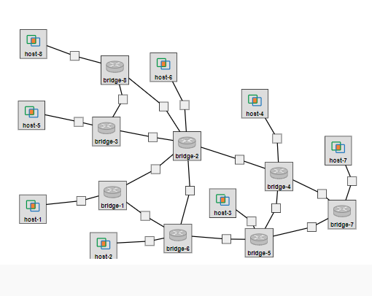

Figure 1: Example Layout of the ELAN

Figure 2: Subnet 10.10.0.0/16

Host-8: @pc1:28609

Eth1: IP 19.1

Host-7: @pc2:28607

Eth1: IP 15.1

Host-5: @pc1:28607

Eth1: IP 10.2

Host-6: @pc1:28608

Eth1: IP 9.1

Host-4: @pc2:28606

Eth1: IP 11.1

Host-3: @pc2:28605

Eth1: IP 12.1

Host-2: @pc1:28606

Eth1: IP 8.1

Host-1: @pc3:28603

Eth1: IP 7.2

Bridge-8: @pc1:28605

Eth1: IP 17.1

Eth2: IP 16.1

Eth3: IP 19.2

Bridge-7: @pc2:28604

Eth1: IP 15.2

Eth2: IP 14.1

Eth3: IP 13.1

Bridge-6: @pc1:28604

Eth1: IP 18.1 Eth2: IP 5.2

Eth3: IP 6.1 Eth4: IP 8.2

Bridge-5: @pc2:28603

Eth1: IP 13.2 Eth2: IP 12.2

Eth3: IP 4.1 Eth4: IP 6.2

Bridge-4: @pc2:28602

Eth1: IP 3.2 Eth2: IP 14.2

Eth3: IP 4.2 Eth4: IP 11.2

Bridge-3: @pc1:28603

Eth1: IP 16.2

Eth2: IP 2.2

Eth3: IP 10.1

Bridge-2: @pc1:28602

Eth1: IP 17.2 Eth2: IP 3.1

Eth3: IP 5.1 Eth4: IP 1.2

Eth5: IP 2.1 Eth6: IP 9.2

Bridge-1: @pc3:28602

Eth1: IP 18.2

Eth2: IP 1.1

Eth3: IP 7.1



Eth2

Eth1

Eth4

Eth1

Eth1

Eth1

Eth2

Eth2

Eth3

Eth3

Eth3

Eth1

Eth2

Eth3

Eth2

Eth4

Eth5

Eth2

Eth3

Eth4

Eth3

Eth4

Eth6

Eth1

Eth1

Eth2

Eth3

Eth1

Eth2

Eth3

Eth1

Eth1

Eth1

Eth1

Eth1

Eth1

Eth1

Eth1

Figure 3: Interface mappings for ELAN



Figure 4: Spanning tree showing the links not included for forwarding packets

Root Bridge

The previous four figures are the results for question 1.

Question 2 Results:

When taking down eth3 from bridge-5, host-2 had 47 ping packets lost and host-3 had 49 ping packets lost during the time it took the spanning tree to repair itself.

When bringing eth3 down a second time from bridge-5, host-2 had 49 ping packets and host-3 had 50 ping packets lost during the time it took the spanning tree to repair itself, which is a consistent trend among the two tests.

Question 3 Results:



Root Bridge

**Conclusion**

The things that I take away from this that I did not already know how to do, would be checking for the route used in the LAN by using tcpdump to check the icmp messages and that you can change the priority of a bridge to manually change the root bridge. Most of the configuration with interfaces and bridges I had learned to do while working for Nokia. However, it was quite interesting building a bit more complex and more sprawling network than I have done before. The only true difficulty encountered was the ensuring of correct IP addresses when jumping around the LAN to check which links in the spanning tree were not being used in a specific implementation of the network. One neat extension that could be done with this machine problem in the future would be to have the students work with routing traffic only to specific nodes in the LAN based on a given set of “security protocols” to illustrate the ability to simulate east-west security amongst an extended LAN.